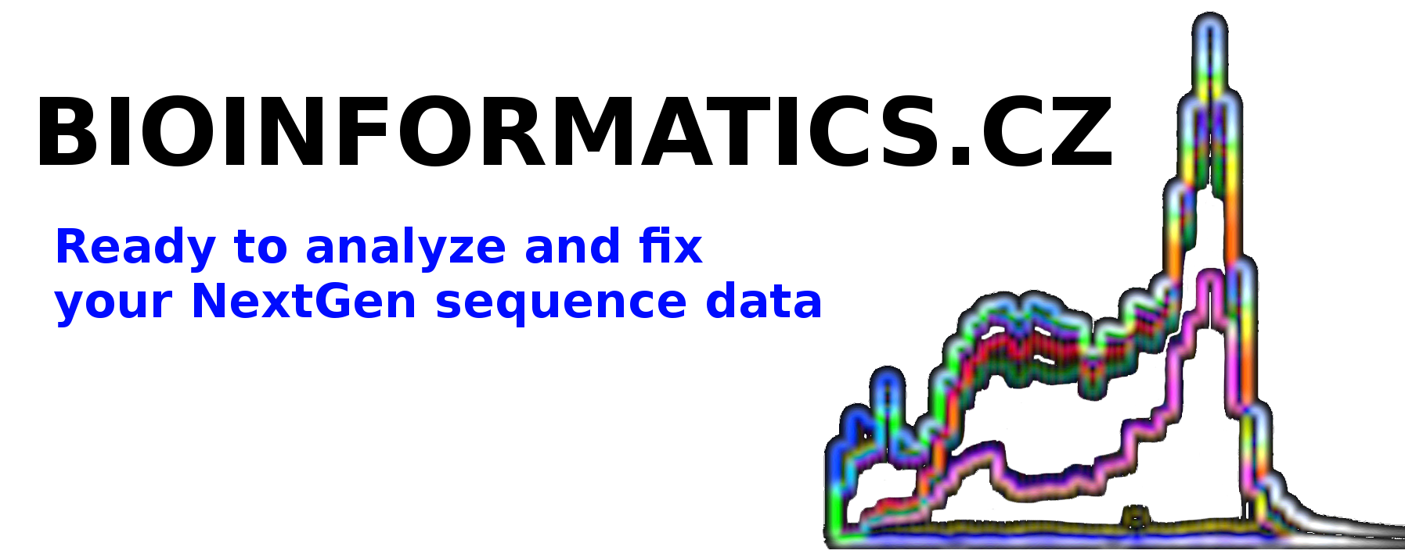

DATA SUBMISSION GUIDLINES

Providing sequencing data in a proper file format for analysis

The file types are listed below in order of their preference.

Roche 454 or IonTorrent technology

1. The preferred file format for submissions is a binary SFF file format. This file format contains the most information about the raw read sequence. If you do NOT have your data in this format please ask your sequencing provider before providing us with data in any of the reduced file formats. Your sequencing provider should be able to provide you with sequencing results in this rich file format upon request.

2. If you cannot provide SFF files the preferred alternative is a FASTQ file format. The data in the FASTQ file should be the original, untrimmed, unprocessed data file as delivered by your sequencing service provider.

3. If you cannot provide even the FASTQ files then you likely have pairs of *.fasta and *.fasta.qual files (still ensure they contain the unprocessed, original raw sequencing data). Please provide both files if possible.

4. Only as the worst case scenario we accept trimmed or cleaned data by a third party. Analysis and correction of such, let us say probably partially processed data, is much more difficult.

Illumina technology

1. The preferred file format is FASTQ. The file should be the original, untrimmed, unprocessed data file as delivered by your sequencing service provider.

2. If you cannot provide the FASTQ file then you likely have pairs of *.fasta and *.fasta.qual files (still ensure they contain the unprocessed, original raw sequencing data). Please provide both files if possible.

3. Only as the worst case scenario we accept trimmed or cleaned data by a third party. Analysis and correction of such, let us say probably partially processed data, is much more difficult.

Compressing the data

The files may be combined into a single archive file, like *.tar.bz2, *.tar.gz or *.zip. However, would the size of such compressed files be over 3-5GB please upload the files individually unless they are .*.fasta and *.fasta.qual files.

Uploading the data

The files can be uploaded by any FTP or SFTP (providing encrypted connection) client program to ftp://ftp.bioinformatics.cz using your personal username and password (will be emailed to you upon order placement unless you have it already). For example, download freely available FileZilla client from SourceForge.

Downloading corrected sequencing data

We will provide you back with corrected files in the same file format as they were received. The download instructions will be emailed to you upon the analyses are completed. For more details on what you get please refer to Data analysis methodology document.

